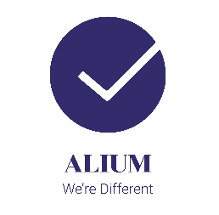
CASE STUDY
SA PROPERTY

Ben got in touch to discuss putting COVID-19 protective measures for his staff and customers in relation to his estate agency business. He asked Alium to provide help with identifying the procedures he needed to put in place for his estate agency offices and for staff completing viewings on properties. We worked with Ben to understand more about his business and whilst looking at the government advice on COVID-19 also considered practical and effective ways to manage his business and protect staff and customers. We supported the development of a COVID-19 risk assessment, safe working procedures and posters/signage.
Ben said ‘We contacted Alium during the COVID-19 lockdown to help us back into the workplace ad to ensure that our working practices would keep staff and customers safe. We found Alium offered us a very comprehensive, easy to understand program to work through, ensuring we all felt safe coming back to work. Very impressive, 100% recommend anyone who needs advice to speak to these guys’
