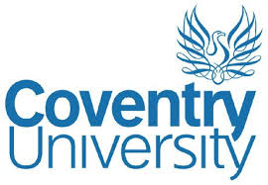

CASE STUDY – COVENTRY UNIVERSITY
At the beginning of 2020, when businesses were required by the government to be @COVID secure’ Coventry University began the immense task of reviewing all their academic provision to meet these requirements.
Due to the magnitude of the task in hand Alium were approached to support the health and safety team support the academic staff in getting this done.
Claire and Louise worked closely with them to help them to undertake their COVID-19 risk assessments and put measures in place to make the campus safe for staff and students.
This was a hugely rewarding role for us in enabling the University and its students to carry on the majority of its activities, in a different way.
We had great feedback from all involved and Karen Lawrence, Head of Health & Safety said:

“Alium have supported a number of our academics and colleagues during the complex task of adjusting practical activities to be COVID-Secure and the supporting risk assessments.
The feedback we have had from across a range of disciplines has been fantastic.
Their pragmatic approach to risk management fits well with our approach and their advice was excellent regardless of the query.
I have no hesitation recommending their service.”

