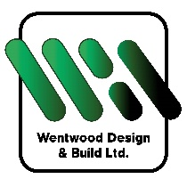
CASE STUDY – WENTWOOD DESIGN & BUILD LTD.
Wentwood design & Build Ltd are a construction company that specialise in design, new build and renovation.
They regularly use general building tools and processes and have previously provided training for their staff and sub-contractors but decided that it would be good to do a refresher session.
Traditionally builders training sessions have concentrated on safety hazards – i.e. work at height, manual handling etc. but there hasn’t been so much training in health hazards e.g. noise, vibration, COSHH (especially dust)
The training session was delivered on site (with coffee and bacon rolls!!) before shift start.
We took the boys through the risks of working with construction dust – wood dust/silica dust, talking them through the effects on the lungs and skin and how easy it is to reduce the amount of dust created by on-tool extraction and wet cutting – showing HSE videos of the difference these controls make
The session was very casual and the boys felt at ease to ask questions. The feedback was that they understood more after the session the reasons why they had to put these measures in place rather than it being just a requirement of work.
Andrew, one of the Directors said:

"Alium Safety were highly informative and very capable.
It was money well spent, we will definitely be using Alium for all our future safety training and professional advice"

