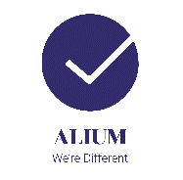
CASE STUDY
HOME AND COLONIAL – PORTHCAWL

After a period of closure during lockdown, due to the COVID-19 pandemic, Stuart, owner of Home and Colonial contacted Alium Safety to ask for support in implementing robust COVID-19 control measures in preparation for reopening the business.
Alium visited the business premises and met with Stuart to gather further information on the shop layout, tasks and activities undertaken and discussed practical options to minimise the transmission of COVID-19. We supported Home and Colonial with the development of a risk assessment to work in conjunction their food hygiene (HACCP) requirements. In addition, we produced safe working procedures, posters and an induction checklist for returning staff.
Stuart from Home and Colonial said, ‘Thank you so much to Alium Health, Safety and Wellbeing for all of your fantastic work making us safe and compliant’.

