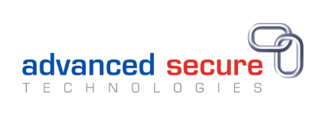

CASE STUDY – ADVANCED SECURE TECHNOLOGIES

Advanced Secure are a global company that specialises in protecting organisations against document fraud.
They have a growing team of sales, IT and marketing staff that spend the majority of their working day at a workstation. They were keen to ensure that their staff were aware of how to set up their workstations, stretch regularly and schedule breaks into their day to ensure that they do not suffer chronic health issues related to workstation use.
They contacted Alium who then proposed that all staff could receive an hour long presentation that brought to life how long-term workstation use can lead to musculoskeletal issues, eye fatigue and other chronic health issues if the equipment, workstation set up and working day are not considered and adjusted – explaining that small changes can make a big difference.
Following the training an individual assessment of each member of staff was undertaken and they were shown how to adjust the chair, how to position the screens and other desktop equipment and how to move and stretch to prevent sedentary positions.
Georgina, one of the Directors said:
‘’The health and wellbeing of our employees is paramount to the business and we found Claire to be fantastic in delivering the presentation and providing the assessments. Her knowledge and experience were exceptional and she was very personable. I would highly recommend Alium Safety to other businesses and we will not hesitate to use them ourselves again’’

